### 

Project plan

Văn Lang Admissions

# Revision Table

|  |  |  |  |
| --- | --- | --- | --- |
| Author | Date | Reason for changes | Version |
| Hien Nguyen |  | Initial the document | 1.0 |
|  |  |  |  |
|  |  |  |  |
|  |  |  |  |

Table of Contents

Revision Table 1

1. INTRODUCTION 3

1.1. Purpose 3

1.2. Definitions, ACRONYMS, and abbreviations 3

1.3. Audience 4

2. Project Overview 4

2.1. Goals 4

2.2. Scope 4

2.3. Deliverable 5

2.4. Constraints, Assumptions, Risks, and Dependencies 9

2.5. Project process 9

3. Project resource 12

3.1. Human resource 12

3.2. Non-human resource 14

4. Project Schedule 14

4.1. Schedule 14

4.2. Milestone 15

# INTRODUCTION

## Purpose

This document provides a plan to approach and complete Van Lang Admission project (methodology and processes), describe resource, schedule, and budget of project.

## Definitions, ACRONYMS, and abbreviations

This following table describes key terms and important acronyms in this project:

|  |  |  |
| --- | --- | --- |
| No. | Term | Definition |
| 1 | BSS | Base Steps Solution Team who develop this project |

## Audience

|  |  |
| --- | --- |
| Intended Audience | Reading Suggestions |
| Project manager | Reading to manage project. |
| Members | Know all activities in project. |

# Project Overview

## Goals

Van Lang University is a non-public university, founded in 1995. Today, the school has 11,000 students enrolled. Every year, the recruitment of 3,000 new students enrolled. So, support systems that promote enrollment, and enrollment management is always an important priority.

This system manages 3,000 new students enrolled each year.

Students, who enrolled to Van Lang, will know all news, and be counseled about admissions by mobile devices.

## Scope

This project has 2 side:

a. Front end

* Look up the enrollment information, information inquiry.
* See a list of applicants, admitted to the
* Registration aptitude exam subjects
* See results aptitude exam subjects
* View and comment admissions advice videos

b. Back end

* User management and permissions features to inquiry
* Content management question / answer: view, reply to candidates, post on the web.
* Manage content short message to the contestants.
* Import, export of data enrollment: export list aptitude exam subjects and images of candidates, put the data submission, the list of candidates admitted in the entrance examination.
* Video Content Management and admissions consulting comment
* Management banner, popup

## Deliverable

|  |  |  |  |
| --- | --- | --- | --- |
| No. | Deliverable | Description | Phase |
| 1 | Project Charter Document | Document describe project. | Kick off |
| 2 | Team rule | Document show team rules, and policy | Kick off |
| 3 | Weekly report | Report each week to mentor about project status. | Monitoring & Control |
| 4 | Effort Log | Review each team member during project. | Monitoring & Control |
| 5 | Risk and Issue List | Record the risks in project | Monitoring & Control |
| 6 | Change Log | Record the changes in project | Monitoring & Control |
| 7 | Estimate Data | Record the results of estimate | Monitoring & Control |
| 8 | Reflection | Description lesson learn while project | Monitoring & Control |
| 9 | Meeting minutes | Content of each meeting | Monitoring & Control |
| 10 | Project report | Description progress of project | Monitoring & Control |
| 11 | Project Plan | Description plan related to project | Planning |
| 12 | Process Decision | Description reason choose project and activity of each phase | Planning |
| 13 | Requirement Plan | Document description the steps necessary when take reequipment | Planning |
| 14 | Work Breakdown  Structure | Document description structure of works in project | Planning |
| 15 | Implementation Plan | Document description exactly what need to done at all times | Planning |
| 16 | Test Plan | Document description the scope, approach, resources, and schedule of intended test activities | Planning |
| 17 | Change Plan | Help management how changes can happen in project and solutions | Planning |
| 18 | Risk Plan | Help management how risks can happen in project and solutions | Planning |
| 19 | Configuration Plan | Document description how to configuration document | Planning |
| 20 | Communication Plan | Document description how to communication with each member | Planning |
| 21 | Measurement Plan | Management measurement method | Planning |
| 22 | Schedule | Description schedule of project | Planning |
| 23 | Concept of Operation  (Con-Op) | Research, review current business processes and proposed business processes. | Requirement |
| 24 | User Requirement Document | Research, review and acquire requirements from user view point. | Requirement |
| 25 | Software Requirement Specification | Research, review and acquire Requirements Specification. | Requirement |
| 26 | Use case Description | Describe detail of all functions | Requirement |
| 27 | Software Architecture Document | Document description architecture of system. | Architect |
| 28 | Database design | Document an architectural database. | Design. |
| 29 | Sequence diagram | Document description architectural database. | Design. |
| 30 | Class diagram | Document description architecture of system. | Design. |
| 31 | Source code | Source code of project | Code |
| 32 | Test Report | Document description result of test process. | Test |
| 33 | Bug Defect Tracking | Document bugs that found in product. | Test |
| 34 | User Acceptance Test | Plan for validating product meet customers’ needs and accepted by customer. | Test |
| 35 | Functional Test | Document description test case of functional need to test | Test |
| 36 | User Guide | Support Administrator and User know how to use product. | Closing |
| 37 | Installation guide | Support Administrator and User know how to install product. | Closing |

## Constraints, Assumptions, Risks, and Dependencies

|  |  |
| --- | --- |
| Constraints | 1. Project lasted 30 weeks.  2. Team has 6 members.  3. Project requires using AngularJS, NodeJS and MongoDB |
| **Assumptions** | 1. Everyone have a smart phone and Internet.  2. 3,000 new students enrolled every year. |
| **Risks and Dependencies** | 1. Using new technology. |

## Project process

a. Process

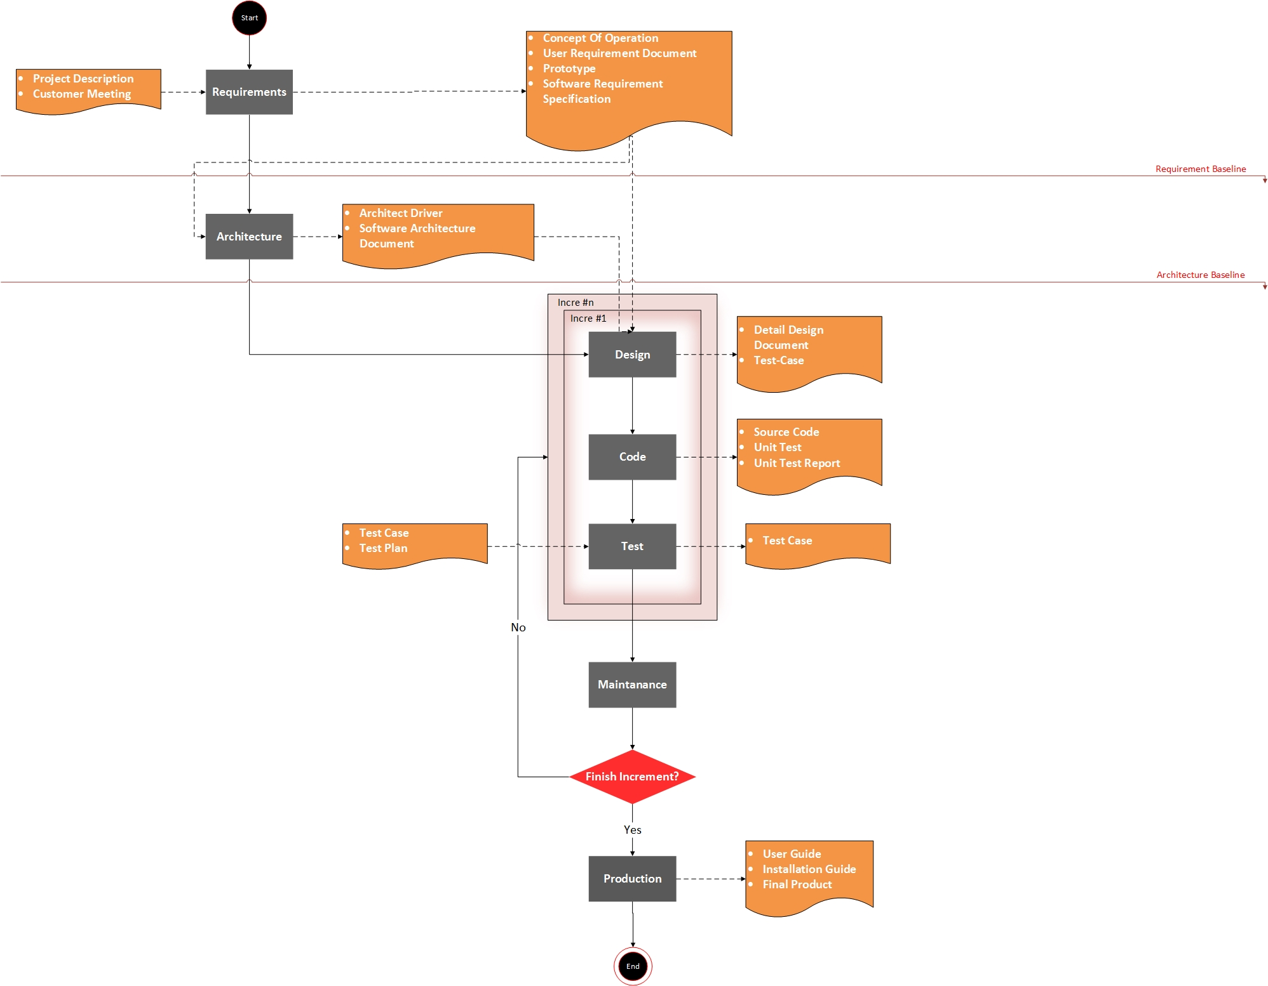

b. Activities

|  |  |
| --- | --- |
| **Phases** | **Description** |
| Requirement | * The Customers provide information about business process of them. * All requirements are fully collected through meetings with customers then analyze and asked, confirm with the customer. * These requests will be evaluated to choose important requirements, so we can arrange priority of requirement. |
| Architect | * The requirements of customers are divided and grouped into sections (modules) each functionality to manage the conduct of software development easily. * Hardware and software are agreed after discussions with customer in meetings. * Analyze quality attribute and trade-off with the customer to bring best thing for customer and team project. |
| Design | * Training Design member * Make use case description, use-case diagram, sequence diagram, database. * Determine all functions, quality attribute |
| Implement | * Training Implement member * Programming all interface and function for the program. |
| Test | * Training Test member * write document: System test, Acceptance test, Summary report, Test case, Bugs List * Run test case |
| Maintain | * Guide customer how to use and install program |

c. Role and responsibilities

|  |  |
| --- | --- |
| **Role** | **Responsibility** |
| Requirement Leader | * Manage about strategy, schedule, resources, and environment to identify, analyze, document and manage requirement of Capstone Project. |
| Architecture Leader | * Discuss the ideas, objectives, requirements and budget of a project and in some cases, help to select a site. |
| Design Leader | * Manage and review about design document. * Redefine a design brief within the constraints of cost and time; * Presenting finalized ideas and concepts to clients or account managers. |
| Implement Leader | * Training for implement member * List task and assign to members * Control each phase of implement process |
| Test Leader | * Define the test tool, the way to perform testing, acceptance criteria for testing, deliverable for testing phase. |
| Project manager | * Managing the project from the first formal documentation of the project’s initiation to its formal conclusion |

d. Process decision

1. Project resource

## Human resource

a. Project organization

|  |  |
| --- | --- |
| Roles | Name |
| Project Manager | * Tran Xuan Hai |
| Requirement Engineer | * Doan Anh Minh |
| Architect | * Tran Xuan Hai |
| Designer | * Nguyen Hoang Anh Tai |
| Programmer | * Nguyen Hoang Anh Tai * Nguyen Thai Hien * Nguyen Anh Khoi |
| Tester | * Nguyen Xuan Thai Hien * Doan Anh Minh |
| Configuration Manager | * Nguyen Anh Khoi |

b. Requirement of Knowledge and Skill Set

|  |  |
| --- | --- |
| **Roles** | **Skill Set Needed** |
| Project Manager | * Communication Skills * **Be highly organized and a good multi-tasker** * **Take charge and know how to lead** * **Be an effective communicator** * **Know how and when to negotiate** * **Recognize and solve problems quickly** * Presentation Skills |
| Requirement Engineer | * Communication Skills * Negotiation Skills * Interpersonal Skills * Analytical and Problem Solving Skills * Documentation Skills * Presentation Skills |
| Architect | * Communication Skills * System Evaluation * System Analysis * Negotiation * Mathematics * Presentation Skills |
| Designer | * Communication Skills * System Evaluation * System Analysis * Documentation Skills |
| Programmer | * Communication Skills * Programming Skill * Mathematics * Problem Solving |
| Tester | * Communication Skills * Logical Thinking * Envision business situations * Respect for truth and intellectual integrity |

c. Training need

* Code Team: Angular 2, NodeJS, MongoDB, Ionic 2, Redis and Elastic search.
* Design Team: database, class diagram, sequence diagram
* Test Team: write test case.

## Non-human resource

|  |  |  |  |
| --- | --- | --- | --- |
| ***No.*** | ***Name*** | ***Purpose*** | ***Requirement*** |
| 1 | Laptop | For team member use |  |
| 2 | Microsoft Office | Tool for documentation | 2013 or higher |
| 3 | WebStorm | Tool for programing |  |
| 4 | GitHub | Tool for management document and code |  |
| 5 | Redis | Tool for management database on cache |  |
| 6 | MongoDB | Tool for management database |  |

1. Project Schedule

## Schedule

## Milestone

|  |  |  |  |
| --- | --- | --- | --- |
|  | ***START*** | ***END*** | ***WEEK*** |
| ***Kick off*** | ***3/10/2016*** | ***16/10/2016*** | ***2*** |
| ***Planning*** | ***17/10/2016*** | ***6/11/2016*** | ***5*** |
| ***Requirement*** | ***7/11/2016*** | ***11/12/2016*** | ***10*** |
| ***Architecture Design*** | ***12/12/2016*** | ***1/1/2017*** | ***13*** |
| ***Incremental 1*** | ***2/1/2017*** | ***26/2/2017*** | ***21*** |
| ***Incremental 2*** | ***27/2/2017*** | ***26/3/2017*** | ***25*** |
| ***Incremental 3*** | ***27/3/2017*** | ***23/4/2017*** | ***29*** |
| ***Closure*** | ***24/4/2017*** | ***30/4/2017*** | ***30*** |

Key milestone

|  |  |
| --- | --- |
| **Milestone** | **Date** |
| Release Plan | 6/11/2016 |
| Release Concept of Operational document | 11/12/2016 |
| Release Software Requirements Specification | 11/12/2016 |
| Release Software Architecture Design | 1/1/2017 |
| Release Incremental 1 | 26/2/2017 |
| Release Incremental 2 | 26/3/2017 |
| Release Incremental 3 | 23/4/2017 |
| Close Project | 30/4/2017 |